EXPERIMENT- 04
Perform Rotation of an Image to Clockwise and Counter Clockwise Direction
Aim
To write a Python code to read an image and rotate the image in clockwise and counter clockwise directions using OpenCV image transformation techniques.
Input Image
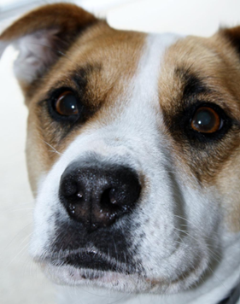
Code
import cv2
from google.colab.patches import cv2_imshow
from google.colab import files
uploaded=files.upload()
image_path=list(uploaded.keys())[0]
image=cv2.imread(image_path)
if image is None:
print("Error: Image not found")
else:
height,width=image.shape[:2]
center=(width//2,height//2)
clockwise_matrix=cv2.getRotationMatrix2D(center,-45,1.0)
counter_matrix=cv2.getRotationMatrix2D(center,45,1.0)
rotated_clockwise=cv2.warpAffine(image,clockwise_matrix,(width,height))
rotated_counter=cv2.warpAffine(image,counter_matrix,(width,height))
print("Original Image")
cv2_imshow(image)
print("Clockwise Rotation")
cv2_imshow(rotated_clockwise)
print("Counter Clockwise Rotation")
cv2_imshow(rotated_counter)
Output Image
Rotated Images
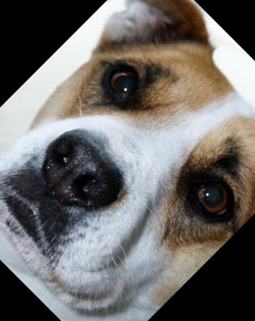 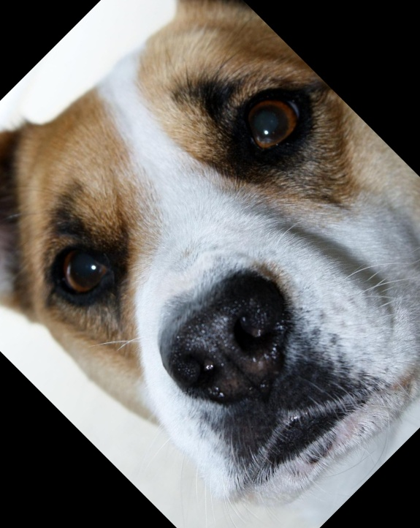
Result
Thus, the image was successfully rotated in clockwise and counter clockwise directions using OpenCV.

